**System Identification of Nonlinear State-Space Battery Model**

Wei He

Department of Mechanical Engineering, University of Maryland, College Park

[weihe@calce.umd.edu](mailto:weihe@calce.umd.edu)

**Abstract**

The goal of this project is to solve the parameter estimation problem of the nonlinear state-space model for the battery state of charge estimation. An Expectation Maximization (EM) algorithm will be employed to solve this problem. The Expectation (E) step involves solving a nonlinear state problem, which will be solved using the particle filter and smoother algorithm in this project.

**1. Introduction**

With the increasing concerns on global warming and fossil fuel depletion, electric vehicles (EVs), which are powered by lithium-ion batteries, will penetrate the automobile market within the next few years. However, there are still some challenges for EVs that remain to be solved. The most notable one is the state of charge (SOC) estimation, which can be used for remaining range prediction of EVs and optimal battery control. SOC by definition is the remaining charge in the battery expressed as the percentage of its maximum capacity. When the battery is full, the SOC is 100%; when it is empty, the SOC is 0 %. To estimate the SOC, a lot of equivalent circuit models (ECMs) have been developed to model the dynamics of the battery system [1-3]. Fig.1 shows a commonly used ECM [1]. In this figure Vt is the terminal voltage of the battery that can be measured by a voltage sensor. OCV is the open circuit voltage of a battery, which is a monotonic nonlinear function of SOC. The nonlinear relationship between OCV and SOC can be established by battery tests. The *R*p and *C*p are the double layer resistance and capacitance respectively, and *R*0 is the series resistance of the battery. Eq. (1) shows the equations of the ECM in a continuous form.

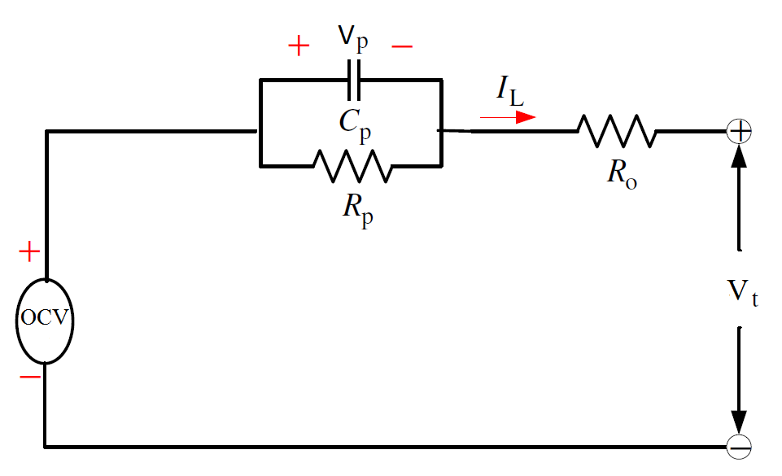

Figure 1 An equivalent circuit model of batteries

 (1)

We can reformulate the Eq.(1) to a state-space representation as follows:

 (2)

 (3)

where *k* is the sampling time and  is the sampling interval.

To model the dynamic evolution of the hidden state *SOC*k, the Coulomb counting principle can be used, which is defined by:

 (4)

where *Q*max is the maximum capacity of a battery.

The combination of Eq.(2), Eq.(3) and Eq.(4) forms the state-space model for the battery SOC estimation. SOC and Vp are not direct observable, so they are the state variables, and Eq.(2) and Eq.(4) are the process functions in the mode. Vt can be directly measured by a sensor, so Eq.(3) is the measurement model. The input of the model is *IL,*k and output is *VL,*k. The measurements of *IL,*k and *VL,*k are assumed to be corrupted by Gaussian noise.

 (5)

Therefore, the model parameters of this model are . The model parameters will change with the loading conditions of batteries. For example, *R*0 may decrease with the increase of temperature. Thus, we need to update these parameters to reflect the true system response, in order to get accurate SOC estimations.

**2. Approach**

This project considers estimating the unknown parametersin state-space models

 (6)

based on the information in the measured input-output responses

 (7)

using a maximum likelihood (ML) framework

 (8)

Eq. (8) is equivalent to maximize a log-likelihood function of YN

 (9)

where  is:

 (10)

Given a set of observed data, a set of unobserved latent data or missing values , and a vector of unknown parameters , the EM algorithm seeks to find the MLE of the marginal likelihood by iteratively applying the following two steps [4]:

1. Expectation step (E step): calculate the expected value of the log likelihood function, with respect to the conditional distribution of given under the current estimate of the parameters :

 (11)

 (12)

1. Maximization step (M step): find the parameter that maximizes this quantity:

 (13)

If not converged, update k->k+1 and return to step 2

It has been proved in Ref.[4] that , which implies that the increase of can insure the increase of the log likelihood of 

When the model (6) is linear and the process noise and measure noise and are Gaussian, then Eq. (11) can be simply computed by a standard Kalman filter. However, in nonlinear and/or non-Gaussian case, other approaches should be employed. In this study the particle filter and smoother will be used to compute Eq. (11). Apply the conditional expectation operator to both side of Eq. (12), we have [4]

 (14)

where

 (15)

 (16)

 (17)

 in Eq. (15) and in Eq. (17) are smoothing problems and can be solved using a particle smoother [4-6]. In Eq. (16), can be rewritten as

 (18)

Therefore, the particle filter and smoother representations can be used deliver an importance sampling approximation to I2 .

If we substitute the particle smoother representation: and particle filter representation: into Eq. (15) , Eq. (16) and Eq. (17), then we have:

 (19)

Eq. (19) provides a solution to calculate for any nonlinear state space model. The EM method with particle approximation is called particle EM in the literature. Below provides a summary of the particle EM algorithm [4].

1. Set *k* = 0 and initialize 
2. Expectation (E) Step:
   1. Run particle filter and particle smoother
   2. Calculate 
3. Maximization (M) Step:

Compute: 

1. Check the non-termination condition . If satisfied update and return to step 2, otherwise terminate.

**3. Implementation**

All algorithms will initially be programmed in MATLAB on a Dell LATITUDE with a 2.67G Hz Intel Core i7 CPU and 4 GB of RAM. The algorithms will initially be developed to run serially. If more time is available, parallel computation of particle filter will be implemented.

**4. Validation**

Simulated data or synthetic data will be used to validate each component: the particle filter, particle smoother and the particle EM. For particle filtering and smoothing, we will generate simulated data with the assumed exact values for the model parameters and states. The nonlinearity-OCV(SOC) may be replaced by a linear function. The states will be estimated based on the simulated data. The root mean square between the real state and estimated state will be used to quantify the accuracy of the filtering and smoothing.

For the validation of the particle EM, simulated data will be generated by assuming exact values for the model parameters. The particle EM will be used to estimate the model parameters 500 times using a Monte Carlo simulation. The mean error and the estimation error variance will be used to quantify the accuracy and precise of the parameter estimation.

**5. Testing**

Testing will be conducted on simulated battery discharge data with assumed parameters. The test will be used to evaluate how well the algorithms perform for constant parameters and for slowly varying parameters. Monte Carlo simulation will be used to study the effectiveness of the parameter estimation algorithms.

**6. Project Schedule and Milestones**

* Project proposal: October 5
* Algorithm Implementation:  
  - for particle filter and smoother: December 1  
  - for the full algorithm: February 1
* Validation: March 15
* Testing: April 15
* Final Report: May 1

Deliverables include the codes of the particle filter, particle smoother and particle EM. The datasets of the simulated battery discharge process. Middle year and end of the year progress reports will also be included.

**7. References**

1. H. He, R. Xiong, and H. Guo, Online estimation of model parameters and state-of-charge of LiFePO4 batteries in electric vehicles. Applied Energy, 2012. 89(1): p. 413-420.
2. C. Hu, B.D. Youn, and J. Chung, A Multiscale Framework with Extended Kalman Filter for Lithium-Ion Battery SOC and Capacity Estimation. Applied Energy, 2012. 92: p. 694-704.
3. H.W. He, R. Xiong, and J.X. Fan, Evaluation of Lithium-Ion Battery Equivalent Circuit Models for State of Charge Estimation by an Experimental Approach. Energies, 2011. 4(4): p. 582-598.
4. T.B. Schön, A. Wills, and B. Ninness, System identification of nonlinear state-space models. Automatica, 2011. 47(1): p. 39-49.
5. M.S. Arulampalam, S. Maskell, N. Gordon, and T. Clapp, A tutorial on particle filters for online nonlinear/non-Gaussian Bayesian tracking. Signal Processing, IEEE Transactions on, 2002. 50(2): p. 174-188.
6. A. Doucet and A.M. Johansen, A tutorial on particle filtering and smoothing: fifteen years later. Handbook of Nonlinear Filtering, 2009: p. 656-704.